Home-Start
Pendle & Ribble Valley
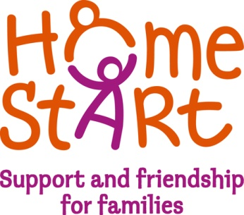

DATE AS POSTMARK
Dear Applicant

Re: Community Genetics Coordinator Vacancy

Thank you for your interest in the above position. Please find enclosed the following:

- Job Description and Personal Specification
- Application form
- Application form Guidance
- Equal opportunities monitoring form

More information can be found at our websites www.homestartpendleandribblevalley.org.uk
www.communitygenetics.org.uk

Applications for this position are by application form only.

Please send your application form to Anne Edington, Senior Community Genetics Coordinator anne@homestartpendle.plus.com or post to the Pendle office.

Please note that candidates should ensure that their application clearly details how they meet the requirements of both the Job and Person specifications.

The closing date for applications is 22nd January 2018.

For and on behalf of Home-Start Pendle and Ribble Valley

